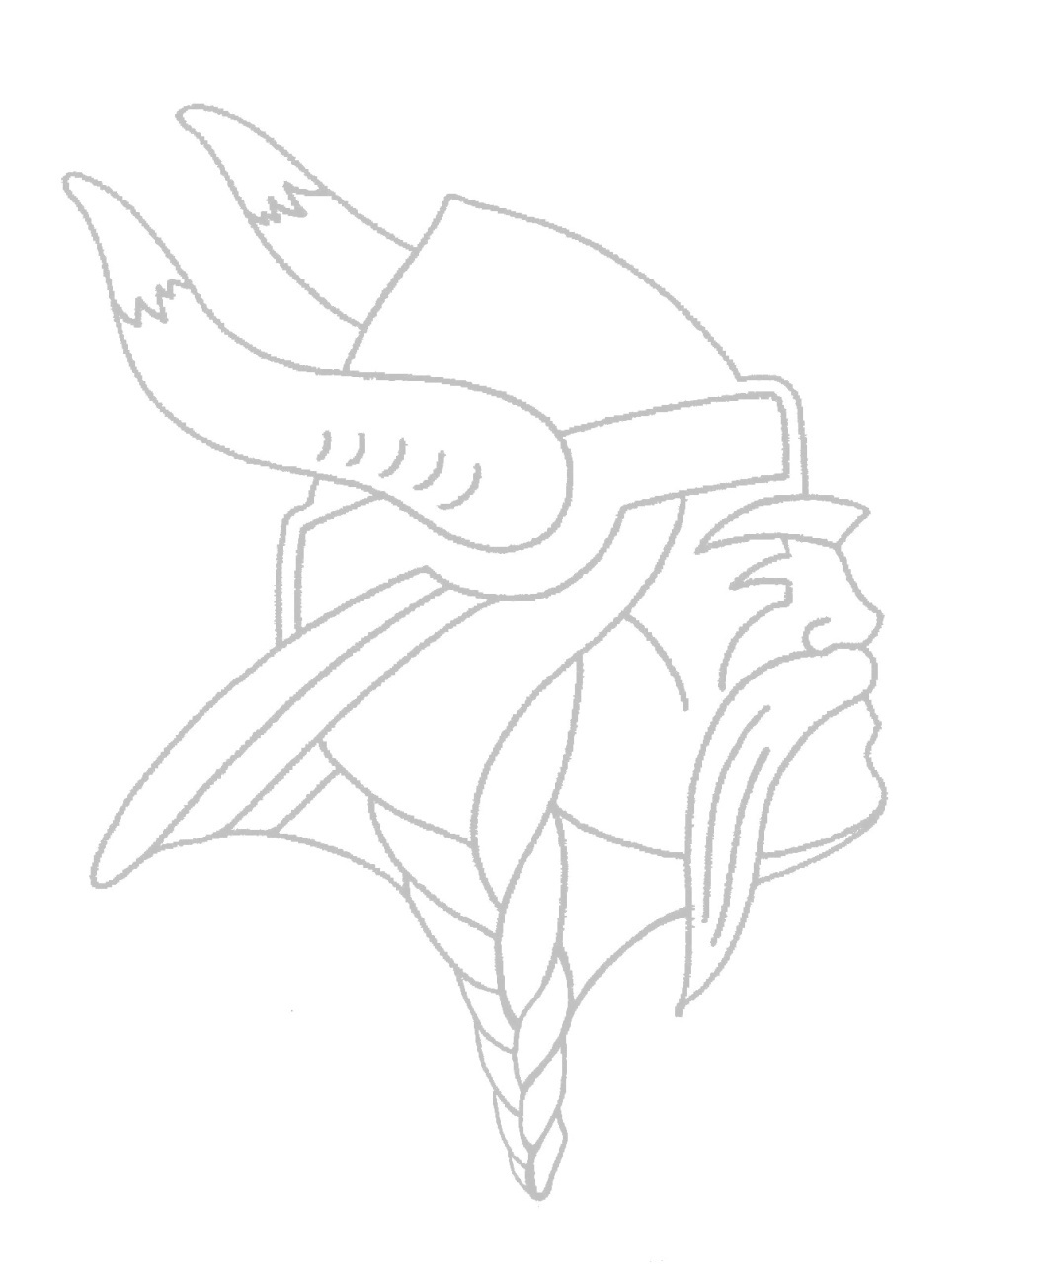GENEVA HIGH SCHOOL BIOLOGY

Dear Students and Parents/Guardians,

Thank you for taking the time to review your student’s Biology syllabus for the year. We look forward to helping your student succeed, enjoy learning and develop an interest in science. Please read over this syllabus and discuss it with your student, then sign and return it to school with them.

Please encourage your student to abide by the cell phone policy, which is to store in it the class cell phone hanger. This not only significantly cuts down on distractions, it also allows us to get to know each other better.

We always love any parent involvement. I am always on the lookout for guest speakers if you or anyone you know works in any scientific fields! Please make a notation below if you can help in anyway.

Feel free to contact us anytime at [ecosky@geneva304.org](mailto:ecosky@geneva304.org) with questions/concerns. However, we ask that you encourage your students to start advocating for themselves and speak to us first if possible. You can always check your student’s progress on HAC, we will make every attempt to keep the grades as current as possible. We are looking forward to a great and engaging year!

Sincerely,

Erin Cosky and Rich Martin

By signing below: I acknowledge I have read and understand the expectations of Biology class, in addition to approving the following:

**Video Release:**

Given the nature of our science content the video clips we work with are often considered PG or PG13. Sign below to give student permission to view PG/PG13 content. If you have any concerns, please feel free to contact me.

Student Name: ___________________________________________________________________

Student Signature: ________________________________________________________________

Parent(s) Name: __________________________________________________________________

Parent Signature: _________________________________________________________________

Biology 2022-2023

RULES AND PROCEDURES

Instructors: Mr. Anderson, Mrs. Cole, Mr. Lesatz, Mrs. Limberis, Ms. Owens, Mr. Raak,

Mrs. Cosky/Mr. Martin

[ecosky@geneva304.org](mailto:ecosky@geneva304.org) rmartin@geneva304.org

Twitter: @ErinCosky 630-463-3954

630-463-5919

Text: Biology Miller & Levine, Savvas Realize (online platform-can be accessed from any device).

Materials: Students are expected to bring the following materials to class every day:

Charged Computer and cord, Pen or Pencil, Stylus, Headphones

Suggested supplies: 3-ring binder, paper, notecards, colored pencils

Topics of Study: Textbook Chapters

*First Semester*

1. Nature of Life 1-2

* Science of Biology + Chemistry

1. Ecology 3-7

* Biosphere, Ecosystems (Dynamics), and Global Change

1. Cells 8, 11, 12

* Cell Structure, Function, Growth, and Division

*Second Semester*

1. Genetics 12-14

* Principles, Processes, Human Genome, and Biotechnology

1. Evolution 17-18

* Darwin's Theory, Evolution of Populations

1. Diversity of Life 19, 21-24

* Classification and Diversity

**Notes and Data**:

Taking notes during class and recording data during labs are skills essential for success in any science class. Lab reports and class notes may periodically be examined and graded so it is essential to keep these necessary materials.

**Assignments**:

Students should be prepared to turn in **homework** at the beginning of class to receive credit. Students can turn in **labs and projects** after the initial due date for up to 70% credit until the chapter assessment. The late work policy does not apply to daily practice assignments that are graded for completion instead of accuracy. To receive late credit a face-to-face conversation with the student’s biology teacher is required (Please do not e-mail your teacher regarding late assignments). Assignments handed in after the chapter assessment will not receive credit.If we cannot read your handwriting, you may be asked to rewrite assignments. Assignments without a name may result in a loss of points.  Extra credit is rarely offered in biology class.

**Academic Integrity:**

The additional use of technology in the classroom has brought new temptations and a new dimension to academic integrity. Students found plagiarizing, copying, or cheating in any fashion **(giving answers is cheating)** will receive an automatic zero for the specific assignment, quiz, paper, or test in which the offense occurred. The expectation is that each of you will make an honest attempt at completing all coursework.

* **Assignments**- What you call ‘working together’ may actually be copying/cheating. There will be a few assignments where you will be assigned 1-2 partners. When you are assigned a partner, you and your partner can have the same answers/work because you were expected to work together. When you are not assigned a partner, sometimes students will still ‘work together’ with someone else however you and this person should not have the same answers and turn in the same work. That is called copying. Some examples. A homework assignment has 20 questions. You do evens and your friend does odds and you send your partner a pic of your evens. That’s called copying. You are working on an assignment. You ask someone what they got for number 7. They tell you and you write it down. That’s copying. You and a friend are doing problem #5. It deals with phases of Mitosis. You are sharing a textbook and look up the section talking about Mitosis. You read it together and then each writes down the answer to the question separately and in your own words. That is NOT copying and is ok.

* **Assessments-** Taking a test and then telling others what was on the test is academic dishonesty. Asking your peers what was on the test is also dishonest. Using any resources besides your brain to answer test questions is academic dishonesty unless approved by your instructor. **There are no test retakes or test corrections for points in biology.**

**Organization:**

Organization is a key component to success in this class. You are encouraged to keep all your work organized in a way that makes sense to you. The final exam is cumulative, so it is essential to retain all important course materials that will help you succeed.

**Classroom Rules:**

# To maintain a positive climate that promotes learning, it is essential that you:

* Use technology appropriately – Per school-wide policy, cell phones are to be placed in appropriate location at beginning of class.
* Come to class prepared and on time
* Treat everyone and everything in the classroom with respect at all times

**Absentee**:

All classroom materials will be made available online. It is your responsibility to understand how to access the resources whether in class, learning remotely, or absent. If absent, follow the procedure below:

1. Check your daily class agenda in Schoology.
2. Obtain and complete assignments.
3. Ask a classmate for clarification, if needed.
4. Speak with your instructor in person if you need further assistance. Please understand that it’s important to complete steps 1-3 first.

**Classroom Discipline:**

The following steps will be taken to keep students on task during class:

1. Simple warning (verbal or visual)
2. Explicit warning and an after-class discussion (possible detention)
3. Removal from class or meeting

** Some behaviors may be so extreme, disrespectful, or dangerous that immediate referral to the Dean’s office is necessary.

**Grades: Grades will be posted in the grade program in a timely and professional manner. Please refer to your teacher for further information on grading policies and procedures.**

Each assignment, quiz, lab, and exam is given a possible point value. Semester grades will be figured using the following breakdown: **Tests and quizzes 50%, labs and projects 20%, homework/classwork 10%, and the final exam 20%.**

# Geneva High School’s standard grading scale will be used

Grade % Grade %

A 91.5- 100 C 71.5- 77.4

A- 91.4- 89.5 C- 69.5- 71.4

B+ 87.5- 89.4 D+ 67.5- 69.4

B 81.5- 87.4 D 61.5- 67.4

B- 79.5- 81.4 D- 59.5- 61.4

C+ 77.5 -79.4 F 59.49 and below

*Assignments that are not handed in will be recorded as NHI (not handed in). An NHI factors as a zero.

*Assignments that are not handed in due to an absence will be recorded as a P for Pending (P factors as a zero) If and when the assignment is completed it will be graded and recorded. Note that if the assignment is not completed or handed in within the allowed time frame the assignment will factor as a **zero.**

**Extra Help:**

If you have questions, don’t hesitate to ask!!! Please self-advocate during the daily designated class time. Use the available in-class time to ask questions. Expect teachers to communicate by email between 7:25 am-3:30 pm.

## LET’S HAVE A GREAT YEAR!